**PGE 383 - Stochastic Methods for Reservoir Modeling - Spring 2019**

Project Update #1 – Dataset 01, Univariate, Spatial Data Analysis

Team No 1

**Executive Summary**

The XXXX reservoir subsurface team has just received delivery of 271 wells in a data table with X and Y coordinates (meters), Facies 0 and 1 (1 is sandstone and 0 is shale), Porosity (fraction), permeability as Perm (mD) and acoustic impedance as AI (kg/m2s*10^6) along with an acoustic impedance map with exhaustive coverage at 10 x 10m resolution over the 1 x 1km area of interest. This update includes the team’s initial univariate, spatial analysis for the purpose of data checking and to formulate initial subsurface hypotheses.

The work included:

* Visualization of data distributions, data coverage, sampling and location maps, including combined and by-facies.
* Sampling bias detections.
* Calculation of summary statistics
* Outlier detection
* Comparison of at-well and mapped acoustic impedance
* Initial interpretations of the depositional setting

The interest area has an acceptable data coverage, however, there are a blank space in the borders of the area, as an indicator of biased well. Also, there appears to be strong directionality in the reservoir property spatial distributions. The property distributions, and geometries are consistent with a weakly confined deepwater channel system. Future modeling work should integrate facies, debiased well-based sample statistics and account for directionality and trends.

**Description of Workflows and Methods**

The following steps where conducted in an annotated Python Jupyter Notebook:

1. loaded csv data files to Pandas DataFrame and gridded ndarray

2. checked summary statistics for invalid values, e.g. nulls and negatives

3. plotting of data distributions and spatial location maps (by-facies and combined)

4. outlier detection (Tukey 1.5 x IQR method, with no distribution assumption)

5. comparison of well and map-based seismic data (Student’s t-test for difference in means, with pool variance) 6. initial interpretation of reservoir depositional setting and architectural element

**Results and Discussion**

**Location Maps and bias detection**– The visual inspection indicates a fair coverage over the interest area, but in the north east and south west areas, there are irregular sampling displaying a biased well location. It opens the opportunity sampling for spacial exploration. Also, the north west area indicates biased sampling in the best property zone showing a denser sampling in very high permeability regions. There is not clear directional trends and geometries associated with all properties. The outliers may provide a better resolution in some properties due to the abroad range in permeability data. Nevertheless, porosity and permeability are directly related, and acoustic impedance and porosity are inversely related.

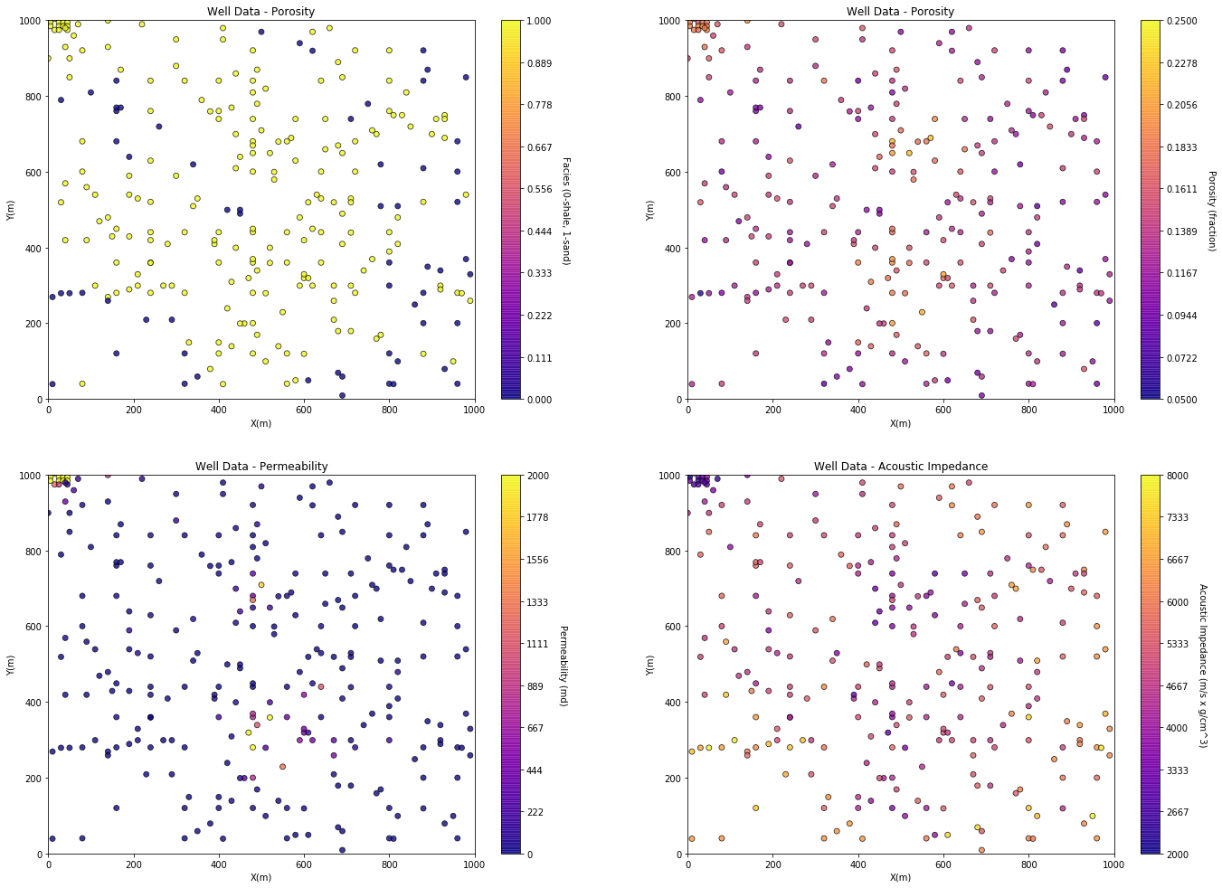

**Univariate distributions / binned PDFs by Facies** – indicate a strong porosity, permeability and acoustic impedance dependence on facies. Facies provide good control on reservoir properties. Summary statistics by facies indicate there are no null values, nor non-physical values.

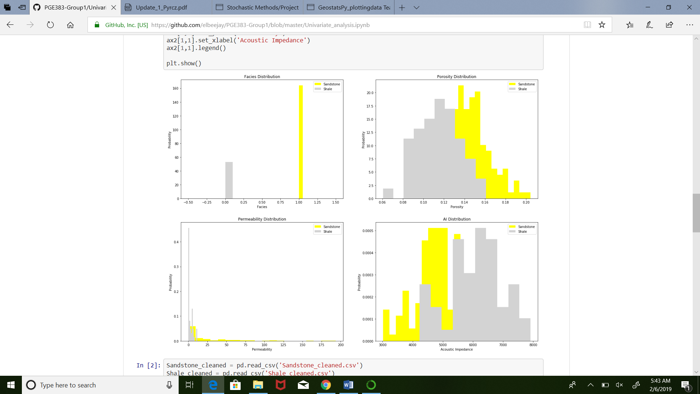

Maybe we can plot translucid regions

**Outlier Detection** – outlier detection was performed with the Tukey, 1.5 x interquartile range method over porosity, permeability and acoustic impedance. The results are shown below.

Include maps of the outlier data detected.

Declustering?

**Comparison of Acoustic Impedance over the Map and at Wells**

Include our plots

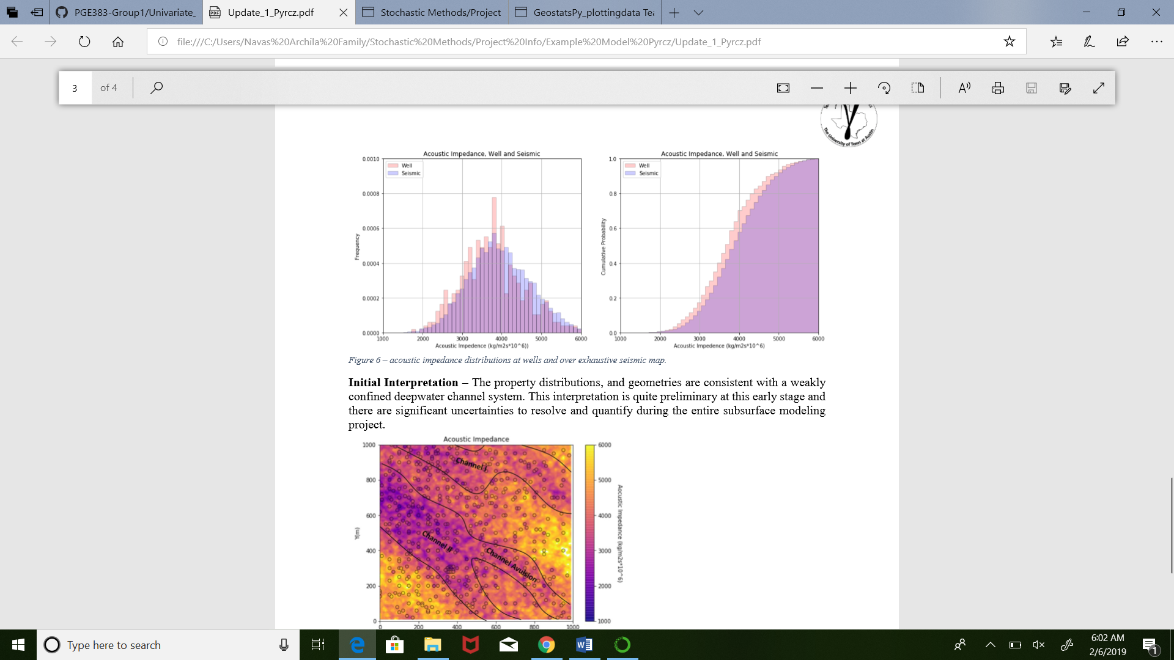

**Initial Interpretation**

Include our interpreted map



**Conclusions**